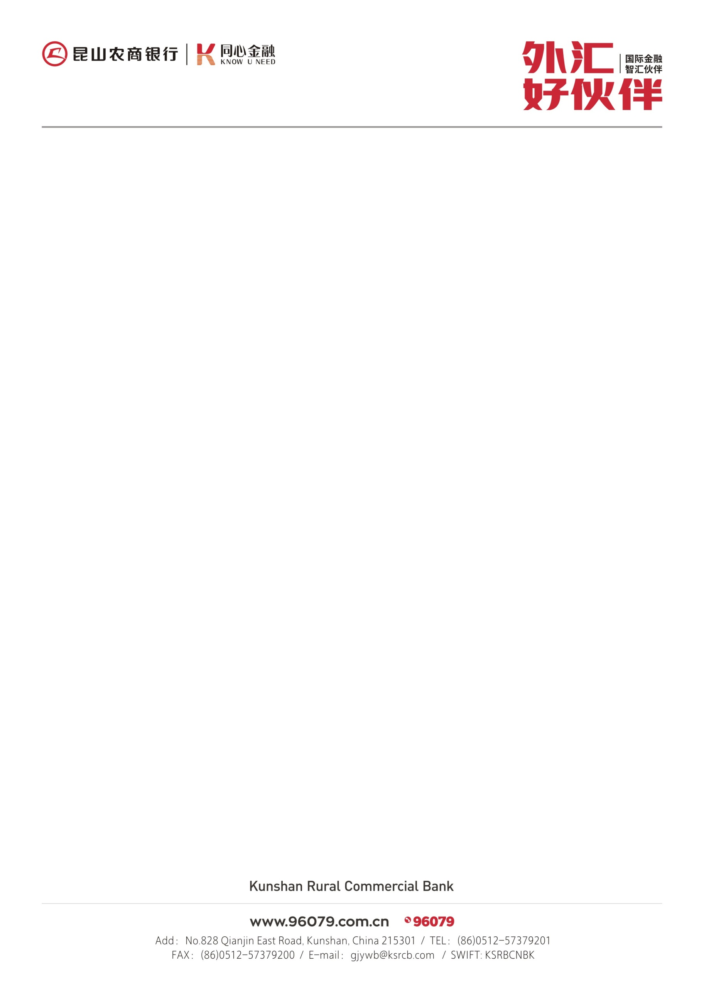

亲爱的客户：

|  |  |  |
| --- | --- | --- |
|  |  |  |

|  |  |  |
| --- | --- | --- |
|  |  |  |
|  |  |  |
|  |  |  |
|  |  |  |
|  |  |  |
|  |  |  |
|  |  |  |
|  |  |  |

为使信用证来证迅速确实，请依以下资讯指示开证至本行客户：

DEAR CUSTOMER：

To make L/C advised smoothly and correctly,please follow the instructions as below：

Advising a L/C through KRCB

来证通知指示

|  |  |  |
| --- | --- | --- |
| ROUTES | ADVISING BANK | SWIFT CODE |
| OPTION  1. | Bank of China,Suzhou Branch  中国银行苏州分行 | BKCHCNBJ95B |
| NO.128 Wangdun Road Suzhou Industrial park Jiangsu Province P.R.China  中国江苏省苏州市工业园区旺墩路128号 |
| OPTION  2. | 中国工商银行苏州分行  Industrial and Commercial Bank of China Suzhou Branch | ICBKCNBJSZU |
| 中国江苏省苏州市阊胥路88号  NO.88 CHANGXU ROAD SUZHOU CITY JIANGSU PROVINCE P.R.CHINA 215000 |



KSRBCNBKXXX

**收款人名称(Beneficiary’S name):**

**Address（地址）:**

**57A :**

**OR**

**57D:Kunshan Rural Commercial Bank;**

**NO.828 Qianjin East Road, Kunshan City Jiangsu Province P.R.China 215301**

请通知开证行在57A或57D上加注由昆山农商银行转通知，以便能迅速转递到我行

**Please mark on 57A OR 57D( Advise through):**

请将您企业英文名称地址填写在空格处，然后将完整的来证通知指示提供给开证方，通知行即可根据此将来证顺利通知您！如有疑问敬请与我行业务人员联络。

**通知行（ADVISING BANK) 以下两条路线二选一：**